**NARROGIN SENIOR HIGH SCHOOL** 

**English ATAR Year 12**

|  |
| --- |
| **Student: Date Due:** Thursday 17th June 2021 |
| **Task 11.**  **Assessment Type:** Responding: Short answer  **Weighting:** 5%  Answer the following questions in short answer responses of 250-300 words per response in the required time frame.  **Time allocation:** One period.  **Conditions:** In class.  **Mark: / 30** |

|  |  |  |  |
| --- | --- | --- | --- |
| **To be assessed for this task you must submit:** | **Date Due** | **YES** | **NO** |
| Short answer responses |  |  |  |

Teacher Feedback:

|  |  |
| --- | --- |
| **CRITERIA AND CATEGORIES** | **Marks** |
| **Question 1: Your response** | **/10** |
| Detailed and sophisticated analysis of text with appropriate evidence and use of metalanguage. Response is succinct, coherent and clear. Minimal errors. | 8 -10 |
| Detailed analysis of text with appropriate evidence related to the question. Response is succinct, coherent and clear with a few minor errors. | 6 - 7.5 |
| Competent response addressing components of the question, supported with some appropriate text-based evidence, with some errors. | 3.5 – 5.5 |
| Limited understanding of text with minimal analysis; retell of text with limited reference to the question, underdeveloped expression, poorly structured response, frequent errors. | 2- 3 |
| Response that does not address the question, minimal control of the mechanics of grammar, spelling and punctuation. | 0 – 1.5 |
| **Question 2: Your response** | **/10** |
| Detailed and sophisticated analysis of text with appropriate evidence and use of metalanguage. Response is succinct, coherent and clear. Minimal errors. | 8 -10 |
| Detailed analysis of text with appropriate evidence related to the question. Response is succinct, coherent and clear with a few minor errors. | 6 - 7.5 |
| Competent response addressing components of the question, supported with some appropriate text-based evidence, with some errors. | 3.5 – 5.5 |
| Limited understanding of text with minimal analysis; retell of text with limited reference to the question, underdeveloped expression, poorly structured response, frequent errors. | 2- 3 |
| Response that does not address the question, minimal control of the mechanics of grammar, spelling and punctuation. | 0 – 1.5 |
| **Question 3: Your response** | **/10** |
| Detailed and sophisticated analysis of text and comparison, with appropriate evidence and use of metalanguage. Response is succinct, coherent and clear. | 8 -10 |
| Detailed analysis of text with appropriate evidence related to the question. Response is succinct, coherent and clear with a few minor errors. | 6 - 7.5 |
| Competent response addressing components of the question, supported with some appropriate text-based evidence, with some errors. | 3.5 – 5.5 |
| Limited understanding of text with minimal analysis; retell of text with limited reference to the question, underdeveloped expression, poorly structured response, frequent errors. | 2- 3 |
| Response that does not address the question, minimal control of the mechanics of grammar, spelling and punctuation. | 0 – 1.5 |
|  | **/30** |

Comprehending

In this section there are **three** texts and **three** questions. Answer **all** questions**.**

You are required to comprehend and analyse unseen written and visual texts and respond concisely in approximately 200–300 words for each question.

Suggested working time: 60 minutes

Question 1 (10 marks)

Analyse how language features and techniques position response to waste disposal in **Text 1**.

*An extract from the 2019 article* Rise of the Fatbergs *by Kelly Oakes, New Scientist magazine.*

The fatbergs are coming! These huge lumps of cooking oil and wet wipes lurk beneath our streets, threatening to block sewers and put everyone off their lunch. And they really *are* huge. In 2017, a 250-meter-long, 130-tonne monstrosity was found in east London and a whopping 800 tonnes of fat were removed from sewers in Cardiff. So, is this a real problem and should we be worried? Tom Curran of University College says there has been a rise in the number of fatbergs and various factors have contributed to it: growing urban populations, ageing sewers, a rise in eating out and our increased flushing of wet wipes.

Fatbergs are made of fat, oil and grease congealed around wet wipes and other things that people shouldn’t flush down the toilet. A 2017 report by Water UK found that 93% of material recovered from sewer blockages were non-flushable wipes. Clearing the UK’s 300 000 annual sewer blockages costs £100 million, it says. That’s a lot of money down the drain. Plenty of other items have been found inside fatbergs but as the name “fatberg” suggests, fat plays an important role in creating blockages. Cooking oil from a pan, excess gravy tipped down the sink and salad dressing rinsed off a plate all contain fats that end up in wastewater pipes. Both commercial and domestic kitchens are culpable, but restaurants take the lion’s share of the blame because they prepare more meals and use more cooking oil than individual homes. It isn’t just places that prepare hot food: baristas who swill away coffee grounds and milk are also feeding fatbergs, says Raffaella Villa of Cranfield University, who analysed the Whitechapel monster fatberg.

What’s to be done? Thames Water is focussing on educational campaigns, both for households and businesses, to stop people contributing to fatbergs. Its “Bin it. Don’t block it.” campaign encourages us to flush only “the three P’s” – pee, poop and toilet paper – and to put cooking oil in a container first and then in the bin rather than down the sink. There are positive signs that its working: the number of blockages is on the decline since the campaign started. Curran has first-hand experience of how problematic wet wipes can be. Before he began researching fatbergs and when his children were small, he used “flushable” wipes for their convenience and just weeks later, the sewer outside his house was blocked. “You can flush a lot of things down the toilet,” he says, “but there will be consequences.”

**Text 2**

A black and white copy of a 2018 poster for the Thames Water Campaign ‘Bin it. Don’t block it.’

Question 2 (10 marks)

Show how **Text 2** represents a similar issue and purpose to **Text 1,** but in a different way.

Evaluate which text you consider is more persuasive.

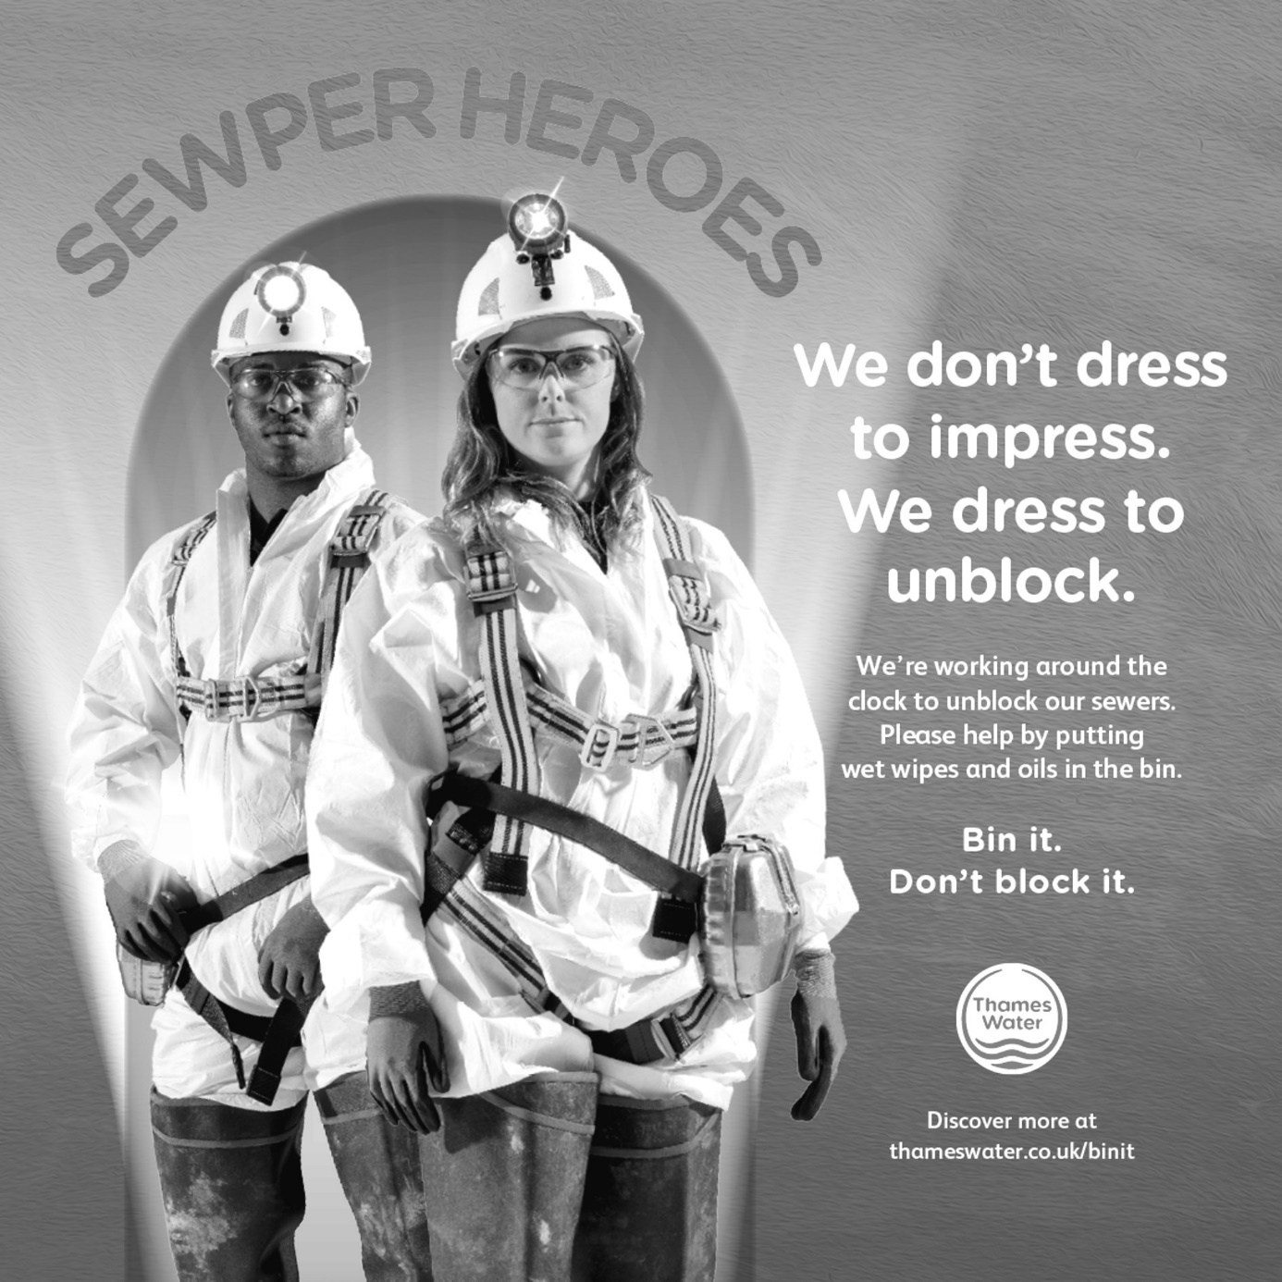

**Text 3**

*An extract from the 2016 novel* The Sun is also a Star *by Jamaican – American author Nicola Yoon.*

Question 3 (10 marks)

How do language patterns and stylistic choices in **Text 3** shape perspectives of cultural context?

When Min Soo fell in love with Dae Hun, she did not expect that love to take them from South Korea to America. But Dae Hun had been poor all his life. He had a cousin in America who’d been doing well for himself in New York City. He promised to help. For most immigrants, moving to a new country is an act of faith. Even if you’ve heard stories of safety, opportunity, and prosperity, it’s still a leap to remove yourself from your own language, people and country. Your own history. What if the stories aren’t true? What if you couldn’t adapt? What if you weren’t wanted in the new country?

In the end, only some of the stories were true. Like all immigrants, Min Soo and Dae Hyun adapted as much as they were able. They avoided the people and places that didn’t want them. Dae Hyun’s cousin did help, and they prospered, their faith rewarded. A few years later, when Min Soo learned she was pregnant, her first thought was of what to name her child. She had this feeling that in America names didn’t mean anything, not like they did in Korea. In Korea, family name came first and told the entire history of your ancestry. In America, the family name is called the last name. Dae Hyun said it showed that Americans think the individual is more important than the family. Min Soo agonised over the choice of the personal name, what Americans call the first name. Should her son have an American name, something easy for his teachers and classmates to pronounce? Should they stick to tradition and select two Chinese characters to form a two-syllable personal name?

Names are powerful things. They act as an identity marker and a kind of map, locating you in time and geography. More than that, they can be a compass. In the end, Min Soo compromised. She gave her son an American name followed by a Korean personal name followed by the family name. She named him Charles Jae Won Bae. She named her second son Daniel Jae Ho Bae. In the end, she chose both. Korean and American. American and Korean.

So they would know where they were from.

So they would know where they were going.